Case Study

EnclosureGuy

Cheri Gerson – March 2018

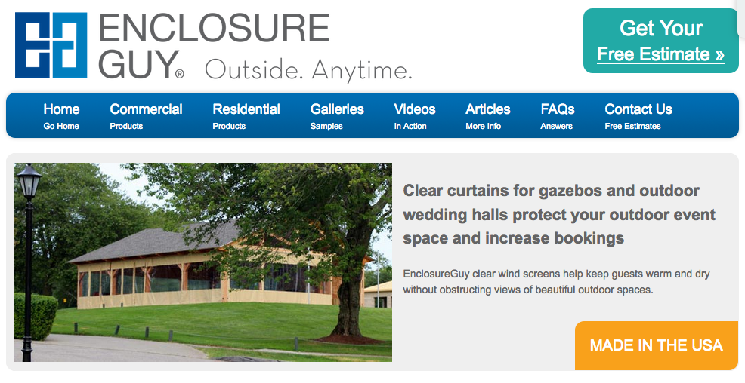

# Why was the competition gaining ground?

Heading into their 35th year of business, EnclosureGuy, the inventor and leading producer of the quality vinyl patio panel, was suddenly and for the first time ever, losing ground. Their competition mosquitocurtains.com and southernpatioenclosures.com were taking away valuable business with nothing big in the pipeline. They needed a solution fast in order to have production for spring to keep the factory going.

## The solution is crystal clear

The answer was simple. This professionally crafted clear vinyl product wasn’t getting its day in the sun. We needed to evaluate their marketing plan to see what we could do for the website and potential customer engagement fast.

Our discovery found that the competition had fresh, interactive websites with easy calls to action including a click to call, get a quick quote and how to find out fast if this product is for them. They were advertising and raising their prices for a lower quality product and the time was now to understand how what we could do to get back at the top.

While we knew that a website refresh was needed to provide better UI and UX to help with education and conversion for both commercial and residential customers with very different needs and budgets, but we had to act fast to get business in the door for March production and delivery.

I analyzed the overall traffic, bounce rate, landing page visits, pricing and nurturing of prospects and previous customers and suggested that we do some analysis and testing with the website before building a new one because many of their pages were ranking well with Google and maybe the problem wasn’t in driving more traffic but rather in conversion. I suggested that we do the following in addition to everything else we had in place:

* Create a competitive features and benefits page to use for a landing page and consider a test run of Facebook ads and AdWords ads to the landing page
* Highlight key differentiators on main banner and add a phone number to the home page
* Offer incentives during slower months
* Reengage previous customers by recommending proper cleaning and inspection pre-and post-season to keep them satisfied and buying additional products
* Create quick quote system to work with salesforce to nurture prospects who might be gathering info, almost ready to buy and those who need a kick start to do it now
* Reevaluate landing pages for further optimization and clearer calls to action
* Use the mailing list of previous customers to offer a purchase of a cleaning kit and encourage inspection for replacement panels as a way to encourage customers to continue using their product over the competition and recommend it to others
* Go back to the mailing list to nurture prospects to act now to take advantage of off season fast and free shipping to be ready for the season.

## The outcome

We agreed to do everything on the list but needed money now to get it all done and keep the business going. The most immediate solution was to go back to the prospects list and create an automated nurturing drip campaign in MailChimp that took a week to build out at a total cost of $200. We gained 10 new sales over 3 weeks to jump started business while we put the other plans into action to keep the momentum going. Each sale ranged from $4,000 to $60,000 with a return on investment from the very first sale.

We rummaged through the tools and strategy looking for a quick and simple risk-free return to fund long term investment. Our strategy in place now will put this company back on top within 90 days with a ROI that will be recouped within 30 days after completion.

Case Study

KeyInfo & KeyCloud

Cheri Gerson – March 2018

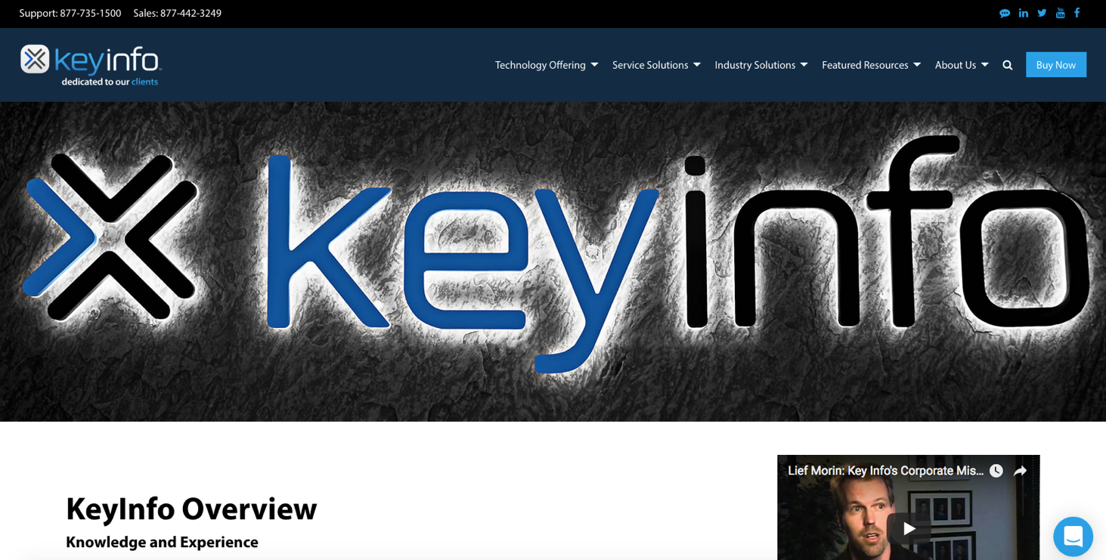

# The problem

After about 20 years of doing business as a top value added reseller (VAR) and service provider for leading technology products like IBM, HP, and Cisco, KeyInfo saw their clients buying less products and moving to cloud solutions and off-prem data storage and redundancy for their data security. KeyInfo’s CEO and team reacted fast with their technology partners to put together a strategy to rival the competition including Amazon AWS. They decided to re-staff the marketing department, buy a data center and build a cloud business called KeyCloud all at once. Leveraging their main business holdings and expertise they set out to build success in one year to serve the needs of customers like Trump Towers, Kings Hawaiian Bread, Fandango and the Port of Los Angeles.

After losing their marketing staff and many customers, they decided to scale back and bring in a fresh approach and younger Marketing Director to augment their senior team who were restructuring the data center and offerings to have the best redundancy and data loss mitigation. Though he didn’t have the background to do it, he was determined to learn from thought leaders and brought in a team to help him carry out the mission to create a new website, great events and marketing collateral to support the sales effort.

In a flash, we went from an antiquated website with outdated data that didn’t tell the story about KeyInfo’s newer offerings and was causing customers to leave fast to the likes of Amazon Web Services (AWS).

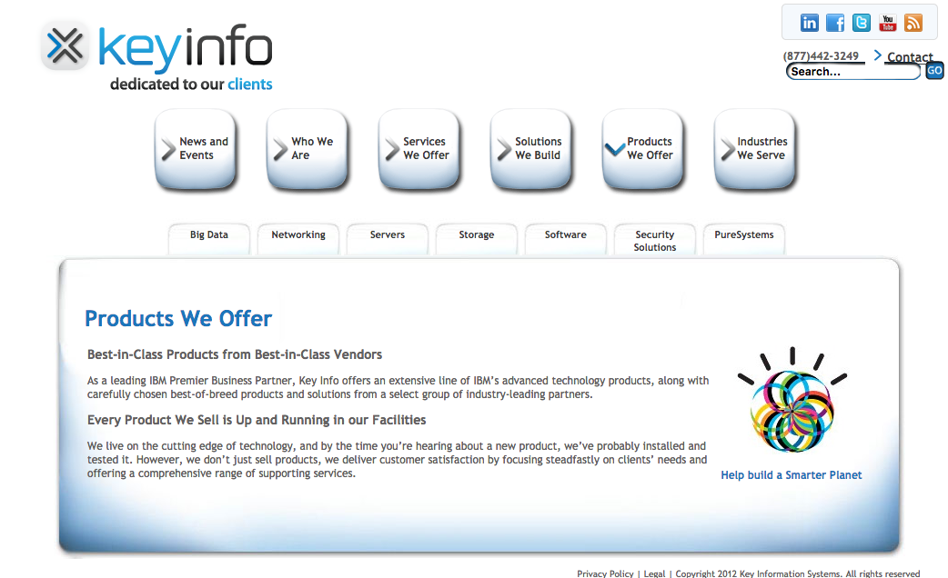

We worked with partners to create EBooks, event landing pages on a new website and quickly became a force to be reckoned with again with landing pages for industry verticals such as real estate, medical providers, consumer products and more with comprehensive as a service products like IaaS to continue to serve clients with big needs like UCLA medical centers.

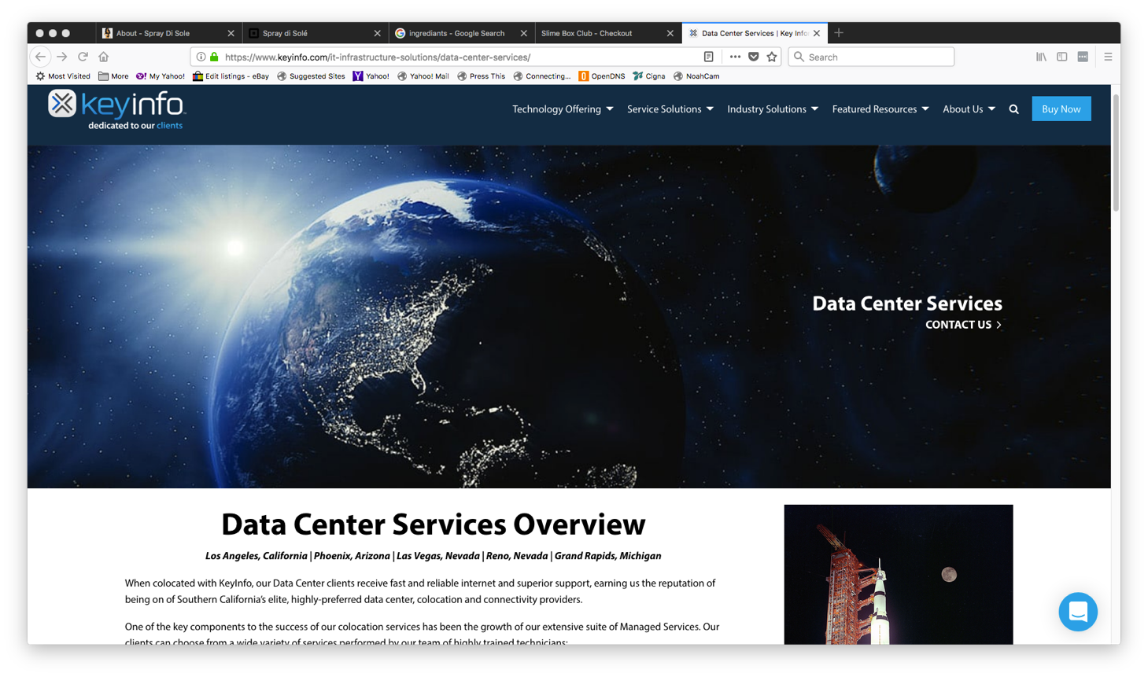

We worked on our funnel and SWOT analysis to determine where clients were in the decision process to ensure they were receiving the right information to make a decision on a product they may not be familiar with to augment the rest of what they were receiving and protect their data in an era of big data. We decided to build a subdomain site for KeyCloud, offering white papers, EBooks, key features and benefits, proof of concept with case studies and a free trial. We used Act-On to augment Salesforce to nurture clients and prospects through the funnel stages and held events to generate interest and keep clients feeling good about KeyInfo.

## 

## Hiccups and results

All this creating a buzz and new solutions all at once came with a high up-front cost and no quick guarantee for ROI. Some of the long-term sales staff and IT department were resistant to change leading to staff turnover and delays in the ROI plan. The decision was made fast to reduce the workforce to a minimum until loans were repaid and the bank would support the efforts needed to continue to grow the business and stay competitive. Today KeyInfo’s CEO is still considered a thought leader and the company is still going strong, building on and off prem solutions by becoming strategic, visionary and capable with the right products, services and teams to serve their hundreds of clients.